**Progress Tracking Guide**

**Cornell Cup USA – Arm Enabled**

**Prof. David R. Schneider, Cornell Director of MEng Studies in Systems Engineering, drs44@cornell.edu**

Keeping track of and continually updating your timeline or the question tree for your deliverables’ can be a good way to monitor your team’s progress. It can be great though to have a way to assess smaller groups’ or individual’s work or recognize where problems may be coming form or determine whether progress rates are justified.

Some teams handle this by asking for regular reports or memos, but those can be both time consuming to write and review, and good memo writing can be a skill in its own right. This guide offers a tried and true variation of a 4-quadrant update that will be referred to simply as the 4QU or QU, (because it’s faster to write or text and you’ll hopefully be using these a lot).

Overall this guide is really 3 guides in one. The guide includes the 4QU as a way to quickly list the major happenings and findings during your most recent work time period (daily, weekly, bi-weekly, etc.) into 4 main topics: Achievements, Outstanding Challenges / Next Steps, Issues & Questions, and Metrics (~4 pages). This guide also adds a quick-to-complete assessment piece that helps provide feedback to both the person creating the 4QU and their team lead / boss (~2 pages). Additionally, the guide begins with some of the most detailed and valuable information on how to set-up your tasks to help ensure your progress tracking will go smoothly (~3 pages).

**Step 0:** In order for this method to be its most effective and to make the later steps very easy and quick to do, it’s important to have each teammates responsibilities well defined with clear and tangible deliverables. Deliverables that are *tangible* are ones that you can physically hand-in or point to specific results to demonstrate/prove that it has been accomplished.

A deliverable that is *intangible* is something that it is hard to tell what was exactly done, or how well it’s been done. Common examples of intangible task deliverables are “do research on…” or “develop an understanding of…” or even “brainstorm around…”. In order to make these deliverables tangible you must connect a tangible outcome to them, and below provides a few examples of how:

* “do research on…” : Compile a list of all of the references that will reviewed. For those that were helpful (minimum 5) provide at least a 1 paragraph summary. Keep a list of all “key topics” that appeared and then for each of your paragraph summaries, add a list of associated key topics so that it will be easy to reference.
* “develop an understanding of…”: Create an example problem with step by step instructions for other teammates to follow. Write this as if it were part of the final report so you don’t have to do it later.
* “brainstorm around…”: Create a list of at least 4 potential options. For each option create a list of at least 3 pros and cons. Be ready to present and defend these pros and cons at the next meeting.

Also notice that the tasks are written with a requirement on the minimum expected effort for the task to be completed, i.e. “minimum 5”, “at least 4 potential options”, “3 pros and cons”. This helps both the task giver and the person doing the task have a way to verify that it has been completed to a satisfactory level.

In some cases, the specification may come from previous definitions. For example, in the third bullet above, what constitutes an “option”? That isn’t really specified. Is it just an idea or does it perhaps require technical drawings & calculations? If you’ve already concretely defined what an “option” is then you may be fine, but just make sure that everyone is confident in what would or would not count as a complete option.

Additionally, it can also be quite helpful to give an indication as to how the task deliverable will be used next. Considering the 3 example bullets above, if you know that someone might search your research by key topics (bullet 1), or follow your example problem (bullet 2), or that you have to present on your work (bullet 3), may help you recognize the level of detail/effort required as well.

Most progress tracking problems can be traced back to deliverables that aren’t tangible, because it makes it very hard for anyone, including you, to demonstrate that they were completed. Beware of the “Awww they know what I mean when I say ‘X’ ” trap. Assumptions like this can lead to teammates coming back with a wide variety of deliverables; someone “doing research” could back with everything from a thought out term paper to someone just looking at the top listing in an internet search for 5 minutes and not having anything to show for it. Making sure you specify what is expected in a tangible manner is the only way to ensure you and your teammates will meet your goals and be recognized as strong contributors.

**Step 0 is Complete When:** It is recommended that everyone on the team write their own tangible deliverables but then verify them with their teammates/team lead.

**Step 1:** Creating tangible task deliverables can be a good way to determine other tasks too. For example, in looking at the “pros and cons” part of the previous Step’s “brainstorm around…” example, one might realize that you and your team are going to have some formal way to evaluate the pros and cons, and explain that evaluation to your boss and stakeholders. Is this pro more important than that con? Is this pro more important than other pros?

By asking these questions, you have recognized that not only do you need options but objective ways to measure the options’ value. So you may want to either:

* Add creating a set of objective performance metrics to this task’s deliverables or…
* Stick with the less formal “at least 3 pros and cons each” deliverable for now so that you can at first get a better general sense of what are some of the driving factors that inform the quality of an option. And then add a separate task later in your timeline to create a set of objective performance metrics

If all the task originally asked for was to just “brainstorm around…” and not have the tangible deliverables associated with it, you might have missed that you also need to plan to spend some time and effort on the performance metrics as well.

Sometimes it’s good to think about defining deliverables, even for your own tasks, as if your task were a multi-part exam problem. What are all of the parts that you would ask for? How would you grade each part to tell whether it was done well or not? Sometimes thinking about what kind of information you need to solve that exam problem can also help to identify additional tasks as well; tasks that are focused on finding that information.

**Step 1 is Complete When:** you have added any needed additional deliverables or tasks to your timeline to ensure the completeness of your planning.

**Step 2: (optional)** In order ensure that the deliverables are not only done, but done well, you may also need to add some assessment criteria. This is typically only done for larger more involved tasks or key milestone tasks but depending upon the complexity of the task and the experience of the person doing the task, you may want to adjust how much you do this.

In general, you’ll rarely be mad at yourself for establishing good criteria but you can become frustrated if the criteria is not well established and you do not get work that is to the level of detail you needed. Formal objective performance metrics for final deliverables to be given to clients/stakeholders are ALWAYS necessary. (see The Defining Client Deliverables Guide) But in the same way that establishing expected performance results with your clients can help manage expectations and nurture a smooth relationship, it can also help your team run smoothly; especially if this is one of the first times you are working together on a task like this or if you are coming from a variety of backgrounds.

**Step 2 is Complete When:** you have added objective performance metrics and expected performance results to your tasks and their deliverables.

**Step 3:** Compare your task deliverables with the next steps in your timeline. Continuing with the multi-part exam question analogy, imagine that you were given the next steps as an exam problem. Do the tasks before those next steps provide you with all of the information you need to successfully complete the next steps, or do you need more? Make sure that the earlier tasks deliverables specify everything that you do need to complete the next steps.

Sometimes it helps to imagine that you were giving these tasks to a separate contractor who would go off to complete the tasks and return with only the deliverables as they were specified. If you feel confident that you could hand off your tasks and get back exactly what you need to progress to the next steps, you have defined your deliverables well.

**Step 3 is Complete When:** You are confident that if you were given the deliverables of your current and past tasks exactly as they are specified, and nothing more, that you would have everything that is needed to complete your next steps.

**Step 4:** Complete your tasks and share your tangible deliverables with your team. And then take a break. You’ve certainly earned it.

**Step 4 is Complete When:** you have completed your tasks, shared your deliverables, and you are ready to compose your 4QU on all of your hard work.

**Step 5:** Copy the provided template PowerPoint in the file ProgressTrackingTemplate.pptx to create your 4 quadrants for your update. Or create a similar 4 quadrants on a sheet of paper.

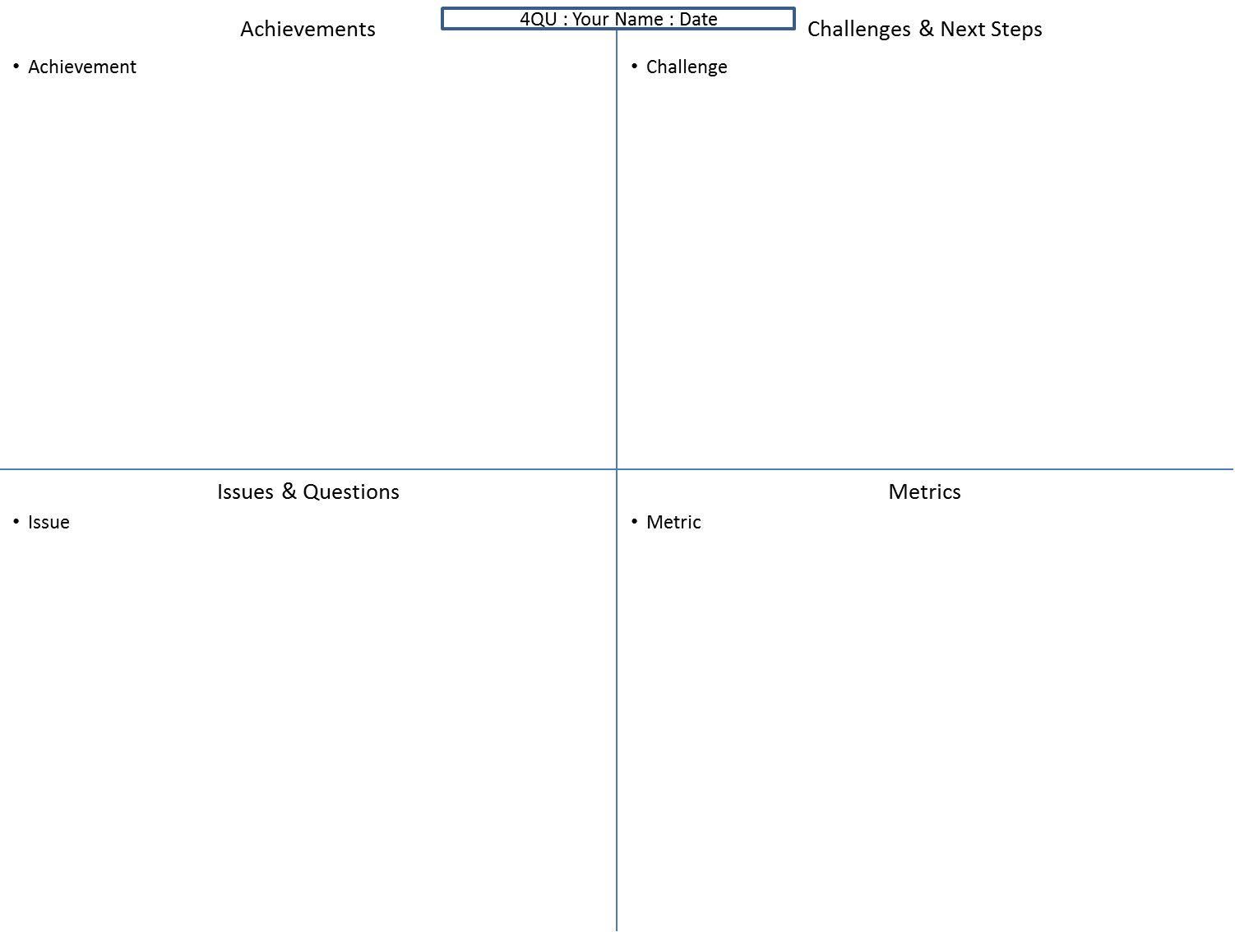

**Figure 1.** Four quadrant template

**Step 5 is Complete When:** You have a slide/sheet with 4 quadrants labeled Achievements, Outstanding Challenges / Next Steps, Issues & Questions, and Metrics or sometimes Achievements, Challenges, Issues, and Metrics for short.

**Step 6:** Create a bulleted list of all of your achievements. This is simply a listing of all of the tangible deliverables you’ve accomplished. Good thing you spent the time to make sure they were tangible. Now it’s quick and clear to say what you’ve done. Even if you’ve only partially completed a deliverable (say you’ve completed 4 of something, when the minimum required for completion is 5) you should indicate your progress.

You may add other accomplishments, even if they haven’t been defined as tasks, but you still feel it’s relevant for the team to know such as:

* Sent a thank you note to our client
* Set up a meeting with the testing facility manager for next Tuesday, 1:00 PM at the testing facility conference room.
* Received the parts for the new communications module
* Asked out Anne on a date and she said yes!

Whether you include personal accomplishments or not is, of course, up to you and your team, so check first, but it’s actually not that uncommon to share in personal victories for the purposes of group bonding.

**Step 6 is Complete When:** You have an accurate synopsis of your achievements during the past time period as a bulleted list.

**Step 7:** Copy from the provided template PowerPoint in the file ProgressTrackingTemplate.pptx or create your own second 4 quadrants chart to list references. This is sometimes referred to as the “4Ref” chart for short.

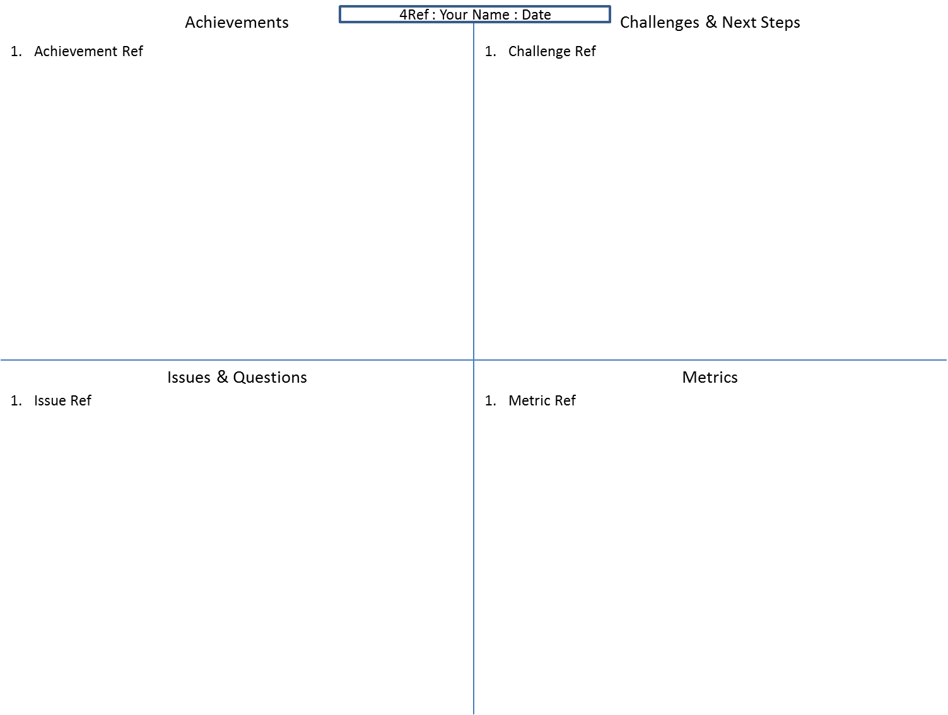

**Figure 2.** 4 Reference template.

**Step 7 is Complete When:** You have a slide/sheet with the header “References” and 4 quadrants labeled Achievements, Outstanding Challenges / Next Steps, Issues & Questions, and Metrics or sometimes Achievements, Challenges, Issues, and Metrics for short.

**Step 8:** At the end of each of your achievement bullets you created in Step 5, add the file name(s) or other location information associated with each achieved deliverable. If the file name is too long to fit cleanly after the achievement bullet, just add a reference instead as you would make a reference to an external source in a formal paper. Then put the full name(s) labeled with the corresponding reference number(s) on the “References”. For example:

In the 4QU Achievements quadrant:

* 4 Potential options created [1], each with 3 pros and cons [2]

In the 4Ref Achievements quadrant:

[1] ProjectFiles/ProjectConcepts/BrainstormOptions1.docx & BrainstormOptions1.xlsx

[2] ProjectFiles/ProjectConcepts/BrainstormOptsProsCons1.docx

Not all achievements will have references, such as the “Set up a meeting with…” achievement mentioned in the Step 6, but listing this information can make it much easier for you and your teammates to find the latest files.

**Step 8 is Complete When:** you have added references, where necessary, to your achievements.

**Step 9:** In your Issues & Questions section, create a bulleted list that summarize any issues or questions that may have arisen that can include

* explanations on the current state of your achievements,
* uncertainty on how to handle something currently
* questions on how to proceed on next steps
* requests for resources and additional help
* unexpected / undesirable results
* upcoming absences

Some examples could be:

* Parts didn’t come in until Monday instead of Friday. Weekend time lost.
* Simulation data demonstrated potential failure that needs to be addressed before testing can be completed.
* How are we measuring the maneuverability of the robot? Have list of potential motors but need metrics to base final motor selection on.
* Do we have any contacts in the machining department that we can reach out to?
* Stakeholder had to move meeting until next week, focused on task #123 instead.
* Need a second person to assist in next stage testing. Is anyone available this week?
* Safety training on equipment is only available bi-weekly; signed up for next session.

Like the Achievements section, you may also add references, perhaps to sets of test data or a copy of an email that demonstrate the issue. Remember though, this section is not to make excuses but to provide explanations and a way of starting a conversation around important topics that influence the continued progress of the team so that you may overcome them.

**Step 9 is Complete When:** you have listed a summary of any issues or questions that have arisen during the past time period.

**Step 10:** In your Outstanding Challenges / Next Steps quadrant, create a bulleted list of your next steps, a.k.a the next challenges you will be undertaking. This is essentially establishing the expected Achievements for the upcoming 4QU. So every week you can compare the Challenges set in the previous week with the Achievements made this week. Many of these Challenges may also be in response to both the Achievements and Issues that you’ve already identified.

To be concise, the task and deliverables’ full description may be listed elsewhere, such as in your team’s timeline where it is indexed by a specific TaskID# (see the Timeline Guide), so it could be quickly looked up if need be. Some examples of what the Challenges might have looked like for the task & deliverables mentioned in Step 0 are given below:

* TaskID#1 Research…,
  + List all sources investigated; summary paragraph for 5 min. Add searchable key topics.
* TaskID#2 Understand…
  + Example problem with step by step instructions for the final report
* TaskID#3 Brainstorm around…
  + 4 potential options with 3 pros and cons each.
  + Present at the next meeting.

**Step 10 is Complete When:** you have created a list of all of the tasks and deliverables for you to accomplish over the next time period. Don’t worry about the length of your Challenges and Achievement lists. Small lists do not mean that great work isn’t being done. Doing a single really hard thing is sometimes more valuable than doing a lot of little tasks and vice versa.

**Step 10a:** Pay particular attention to include tasks that involved contacting an expert or a stakeholder. Keeping everyone on your team informed of who is contacting who and when, and with regards to what can help your team continue to be seen as professional as well. For example, you wouldn’t want to face a situation like this:

Your Teammate: “Hello [stakeholder’s name], I wanted to ask you a couple questions about X, Y, and Z.”

Stakeholder: “I just had a conversation with one of your team yesterday about X, Y, and Z. I don’t have time to go over this again…”

Hence many teams also keep a running log of their conversations with others. It can also be helpful to summarize the results of each conversation.

**Step 10a is Complete When:** You have recorded and informed your team of who you are planning to call, when you’re planning to call them, and what you’re going to discuss.

**Step 11:** In writing your Challenges and Next Steps, if you’re planning on doing work that isn’t in the timeline, add it to the timeline now. This can happen quite often, particularly with adding new tasks to respond to your Issues.

Including these tasks in your overall timeline is very important so that you and your team can keep track of the overall effort. Sometimes this may make you realize that a new task you thought of adding isn’t as important as you might think and should actually be eliminated. Or you might realize that this new task should take priority over other previously developed tasks and hence a reallocation of project resources or even redefinition of project scope is warranted.

Overall, this step not only helps everyone grasp all of the work being done but it can also help you to take time to look at the over the entire project and make sure you aren’t too focused in just one area.

**Step 11 is Complete When:** your timeline is updated with any newly identified tasks with tangible deliverables. Steps 9-10 may often be take the longest to complete if there are new tasks being added. But this is more a result of continuing to do good project planning, rather than just trying to track your progress.

**Step 12:** Add a bulleted list of any key supporting metrics for your Achievements and/or Issues. Many times the metrics reported here are supporting data, such as key test results, government regulations, pricing from a potential vendor, or changes in the performance metrics such as:

* Estimate that subsystem’s X overall performance will increase by 10%,
  + although there is a 5% loss for top speed
  + but a 20% increase in maneuverability criteria
* Testing verified that a minimum performance of 3.2 is now achievable up from a past tested value of 2.6.
* Top speed achieved was 1.2 m/s, Max accel. 3.0 m/s2, Maneuverability score through the test course as 20.3!

References to data sets or calculations are very common as well. Sometimes if there is too much data to include here, just the reference is listed with a brief description such as “Motor controller test results [10]” or “Motor vendor price quotes [11-14]”. It is not uncommon to include graphs, pictures, data tables, etc. as appendix slides at the end as an extension to the Metrics quadrant as well.

**Step 12 is Complete When:** A list of key metrics and information that supports your other quadrant’s statements is listed.

**Step 13:** Take a break. Depending on the number of new tasks you had to create, creating the 4QU and updating the time line typically takes somewhere from 20-40 minutes so be sure to plan for that as part of your routine for every time period. The first couple times may take the longest but as you can often copy and paste Challenges from the last week into Achievements of the next, and as you are often making updates to references instead of new ones, it can start to go more quickly. Every once in a while, especially if you’ve had to move in a new direction, it will take you a bit longer but once you get the hang of it, it can really help.

The final Steps are filling out some quick rubrics that typically take about 5 minutes or less but can help you both provide an assessment of your work to your boss/team lead and your boss/team lead provide an assessment to you.

**Step 13 is Complete When:** you’ve had the chance to catch your breath and are ready to give a quick appraisal of your overall work for the time period.

**Step 14:** Score yourself on your overall progress. This isn’t just to think about how well you met your requirements but to also recognize ways you can excel. Every project can have its own ways of measuring performance & progress below are some good examples to base yours on:

* **Achievement Completeness:** Were all of the deliverables achieved?
* **Achievement Quality:** Are the achieved deliverables done well? This one is often the most project specific and can be split into multiple scores for multiple achievements/deliverables, especially if metrics have been established back in Step 2.
* **Achievement Rigor:** Is there a good sense of thoroughness to the work? This may be covered in the quality, but it’s often good to call out specifically? Someone may have done very good quality work on the work that they did, and technically completed the deliverables, but the work done still doesn’t address all that the task was intended to. Low scores here may be an indicator that the deliverables need to be spelled out better in order to improve this score.
* **Issues Completeness:** Do they accurately portray the issues that are occurring? It’s okay to have issues. It’s not okay to ignore or be quite about them.
* **Issues Appropriateness:** Should these issue have been something that you should have planned for? Did you handle the issues well as they arouse?
* **Task Planning :** Are tasks and tangible deliverables well defined? Is the timeline up to date? Is the 4QU completed well?
* **Resource Planning:** Are tasks being accomplished on time? Were proper resources, including people and equipment, estimated for and dedicated to the task? And without double booking resources?
* **Metrics:** how well do they support the claims/conclusions? Are good records being kept on all calculations, testing results, etc. that will allow other teammates be able follow and use your work?
* **Documentation**: Was clear and complete documentation written to allow someone else, new to the project, be able to replicate your work? And understand your decision process so they could come to the same conclusions you did?

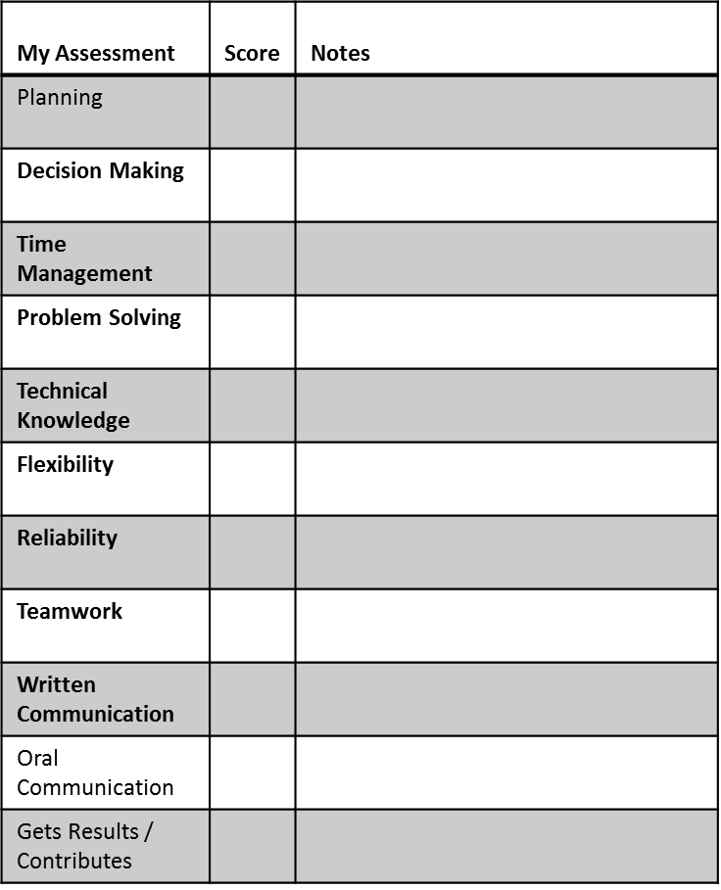

You can develop objective criteria for each of these as well (see the Decision Matrix Guide) but again this may be very project specific. You may also want to add a brief note pointing to the reason why you have given a score that was either low or high.

**Step 14 is Complete When:** you have given a score for yourself in each one of your progress categories.

You can do this by assigning grades but grades have a certain conception were an “A” is doing good, an “A+” is exceptional, and anything less than an “A” is bad. This really doesn’t help you to both look at feedback as an opportunity to see where you need to grow nor really provide you much room to excel and shine.

Instead a 5 pt scale is recommended. A score of a “3” means that you’re meeting your requirements and doing well. “4” is that you have excelled beyond expectations. And it should be difficult to earn a “5” and perhaps be rather rare. Similarly the difference between a 2 and a 3 should be the same as between a 3 and a 4. Below is a generic definition for the 1-5 scale from Prof. Paul King at Vanderbilt that you may use directly or base your own on:

5 Greatly exceeds expectations on challenging work

4 Consistently accomplishes far more and/or performs far better than expected

3 Performs to expectations, meets minimum requirements

2 Sometimes meets minimum but requires improvement

1 Unsatisfactory performance and/or notable deficiencies

**Step 15:** Add checkboxes for any regular duties that should be performed by you. Below are a few examples; the first 2 should be a must for any project:

* timeline updated
* documentation written
* cleaned equipment
* changed & charged batteries
* checked & updated supply inventory
* entered timecard information
* collected the team’s 4QU, etc.

Sometimes it’s better to have the person record a date next to each of these rather than just checkbox, for example “last time equipment was calibrated”.

**Step 15 is Complete When:** you have completed your checkboxes appropriately.

**Step 16:** Ask your boss, team lead, or even a teammate to assign you scores as you did for yourself in Step 13. Then review the scores that you assigned yourself and the scores your boss/team lead/teammate assigned and discuss any differences. This should not be looked upon so much as a “grading” event, but rather an opportunity to see where you can do better and where you are doing great. Both are valuable because you need to know what to fix to work at it and you need to know what you’re doing great so you don’t accidently make incorrect changes there.

**Step 16 is Complete When:** you and your reviewing boss/team lead/teammate have gone over how you both have scored the current progress and you’ve made any agreed upon adjustments to your Outstanding Challenges/Next Steps section of your 4QU.

**Step 17: (optional)** This last Step offers some additional “softer” criteria also from Prof. Paul King at Vanderbilt you may want to score yourself and be scored on. These criteria are sometimes only completed with every major milestone or perhaps on a monthly or quarterly basis. You can do it on a weekly basis as well as it only takes an additional 5 minutes to do.

* Planning
* Decision Making
* Time Management
* Problem Solving
* Technical Knowledge
* Flexibility
* Motivation
* Reliability
* Teamwork
* Written Communication
* Oral Communication
* Gets Results/Contributes

**Step 17 is Complete When:** you and your boss have both completed your assessment of you using the above or similar criteria and you’ve had the chance to discuss it.